Article Title
Name Surname
Article URL

Policeman’s Helmet Soup
Volume X, Issue X, YEAR
The Policeman’s Helmet Sout Journal is supported and published by Dublin City University Library and the School of English.
https://phsjournal.ie/

© 2026 by Author Name. This article is made available open access through a Creative Commons Attribution License, CC-BY-4.0 https://creativecommons.org/licenses/by/4.0/, which allows redistribution and adaptation of the article so long as attribution is given to the original author(s) and source.
Citation
MLA Style (9th edition, in-text citations)
Published: xx/xx/xxxx

Article Title
Article Subtitle
Author, Institutional Affiliation, City
Article URL

Abstract
An informative 11-point abstract (150 to 300 words) presenting the main points of the paper and conclusions. Please include 3 to 6 descriptive keywords separated by a semicolon. The abstract should be written and pasted here. .
Keywords: word; another word; lower case except names

Correspondence regarding this article should be directed to the Corresponding Author(s): Author Name, email address, et al.
Author biography
Conflicts statement: There are no known conflicts of interest to disclose.

Heading 1: Use this style for level one headings
Paragraph: use this for the first paragraph in a section, or to continue after a block quote.
New paragraph: should be indented by one tab.
Quotations longer than 40 words should be marked using the quotation style.
- For bulleted lists
- For numbered lists

Heading 2: Use this style for level two headings

Heading 3: Use this style for level three headings

Heading 4: Use this style for level four headings

Table 1.
Name of the table
Variables |  | N | Mean/ %
Age | 18-21 | 150 | 96.8
Age | other | 5 | 3.2
Gender | F | 117 | 75.5
Gender | M | 38 | 24.5
Grade level | Freshman | 30 | 19.35%
 | Sophomore | 42 | 27.10%
 | Junior | 65 | 41.94%
 | Senior | 18 | 11.61%

Figure 1.
Name of the Figure
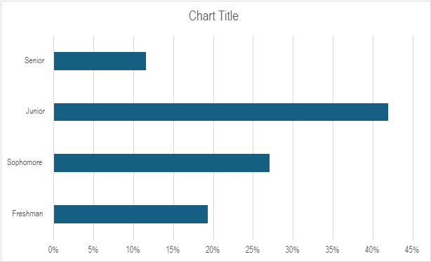

References: Use level one heading style
References should follow MLA Style (9th edition, in-text citations), employ a hanging indent, and correspond to an in-text citation. Authors must ensure that they have listed permanent identifiers (DOIs) for each reference and that all stable URLs are active and direct readers to the targeted materials.

